A simple Program in Java
- class Main {
public static void main(String[] args) {
System.out.println("Hello Jiya");
}
}

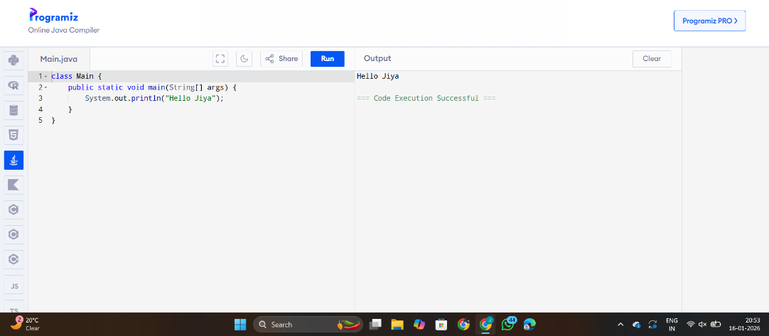

- class Main {
public static void main(String[] args) {
System.out.println("Jiya\tArya\tDeva\tShree\tSamruddhi\tRK");
}
}
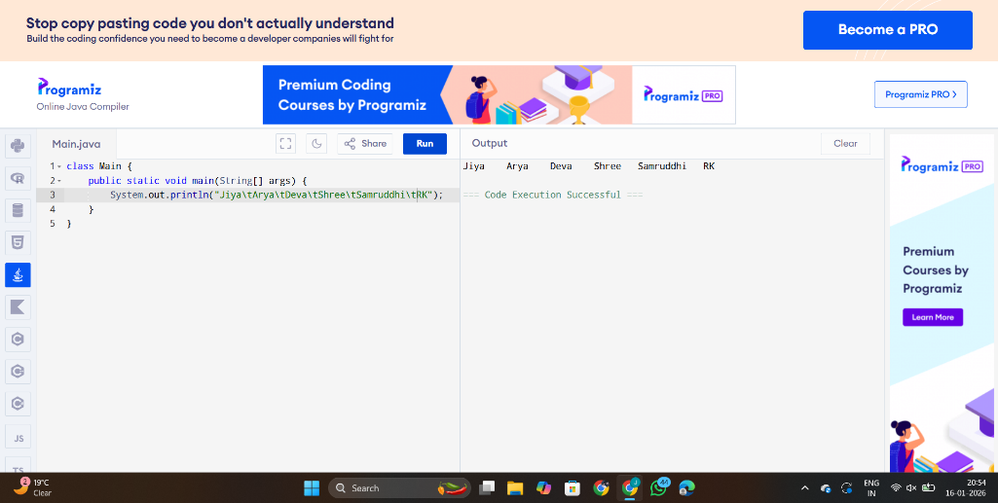

- class Main {
public static void main(String[] args) {
System.out.println("Jiya\tArya\tDeva\tShree\tSamruddhi\tRK");
}
}

